Following are the screenshot of UI components.

Two menu added on top Add and List.

1. Add Component

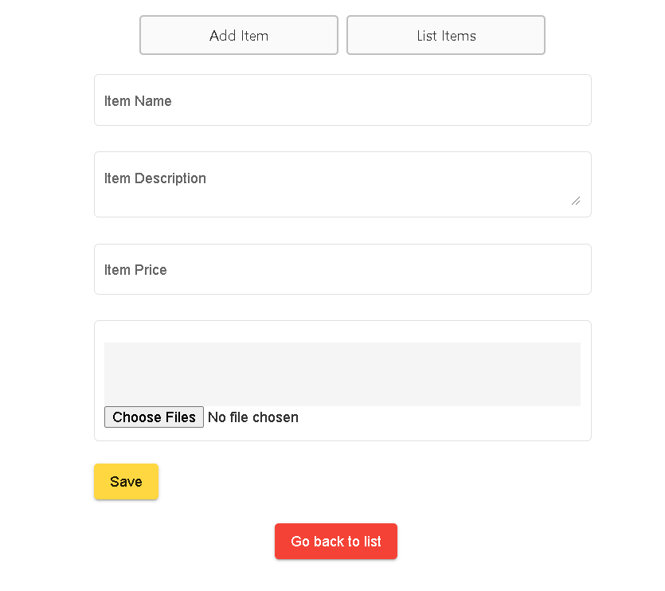

1. Mandatory validation on add component

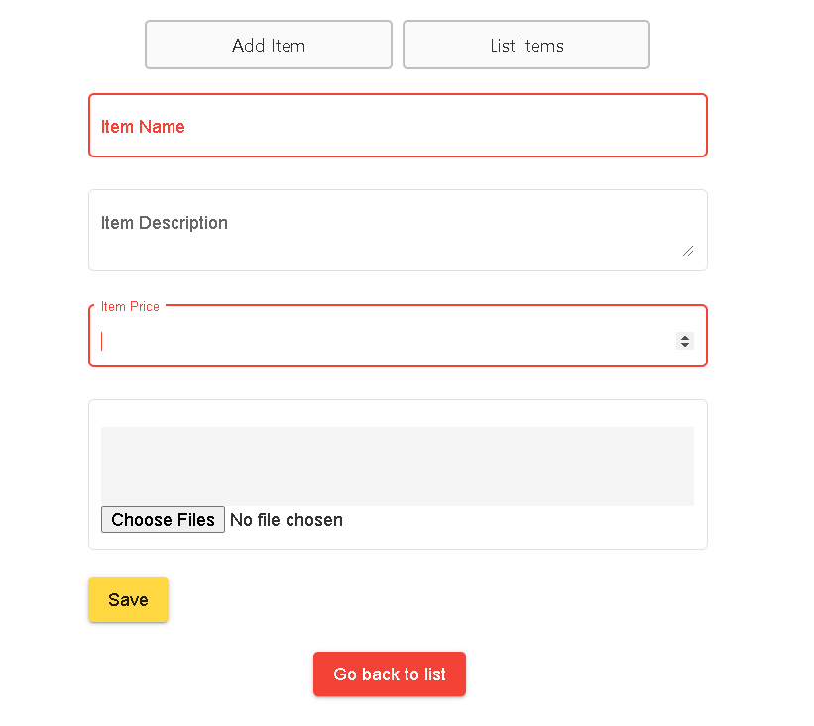

1. List component – all items in inventory is listed and by clicking on Item name we can check the details for the same.

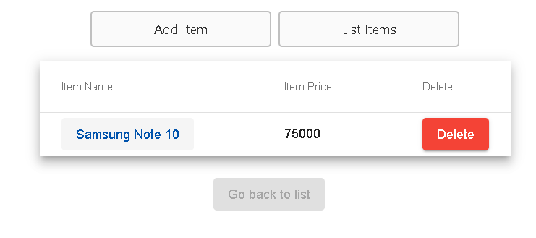

1. Item detail component

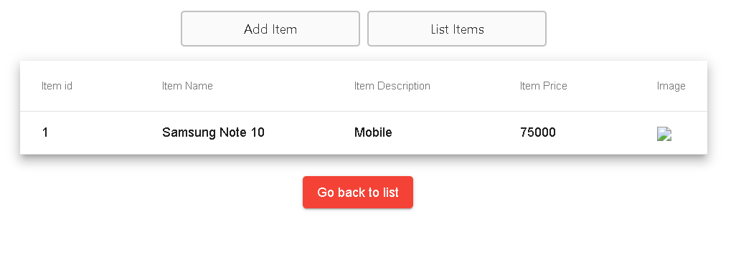

Here we can check all the filled details.